**TASK A**

Web server

* A web server is a program or hardware used to running this software that can satisfy client’s requests on/within the World Wide Web.
* A program that uses HTTP for serving files that create web pages for users in responding to their requests that are sent by the HTTP clients of their computer is called a web server

Architecture of the web server

* Web server architecture is a logical layout or design of a web server, based on which web server is designed, developed and deployed.
* It gives the architectural layout and components of a web server.
* It’s essential for delivering the required web server - based operations and services.

How the different parts of the web server interact

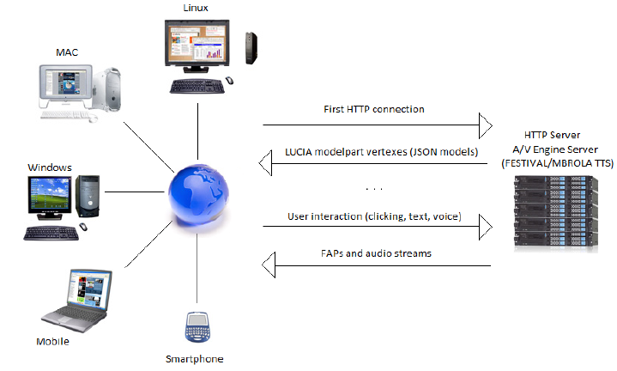

* The primary function of an internet server is to store, process and deliver websites to clients.
* The communication between client and server takes place using the Hypertext Transfer Protocol (HTTP).
* Pages delivered are most often HTML documents, which can include images, style sheets and scripts additionally to the text content.
* Multiple web servers is also used for a high traffic website; here, Dell servers are installed together getting used for the Wikimedia Foundation.
* A user agent, commonly an internet browser or web crawler, initiates communication by making letter of invitation for a selected resource using HTTP and therefore the server responds with the content of that resource or miscalculation message if unable to try and do so.
* The resource is usually a true file on the server's auxiliary storage, but this can be not necessarily the case and depends on how the online server is implemented.
* While the first function is to serve content, a full implementation of HTTP also includes ways of receiving content from clients.
* This feature is employed for submitting web forms, including uploading of files.

Types of web servers

1. Apache HTTP server – is one of the most used web servers worldwide
2. Microsoft Internet Information services – a product that offers almost all the features that Apache HTTP server provides
3. Lighttp – is a combination of “light” and “http” and was released in 2003
4. Nginx web server – known for the performance that it provides at a low resource and configuration
5. Sun Java System Web Server – it is a multi–threaded and multi-process web server that provides high performance.

**TASK B**

This is the link access my project 1 website: <http://assignment222.000webhostapp.com>

Ofentse Miles Mapheto (576865)

WPR – 171

Project 2